Artist: Phal:Angst  Album: Black Country  Label: Bloodshed666 Records (bs11)  Distribution: Hoanzl (aut), Cargo (world), Ordis (digital)  Release date: 14.11.2014 | 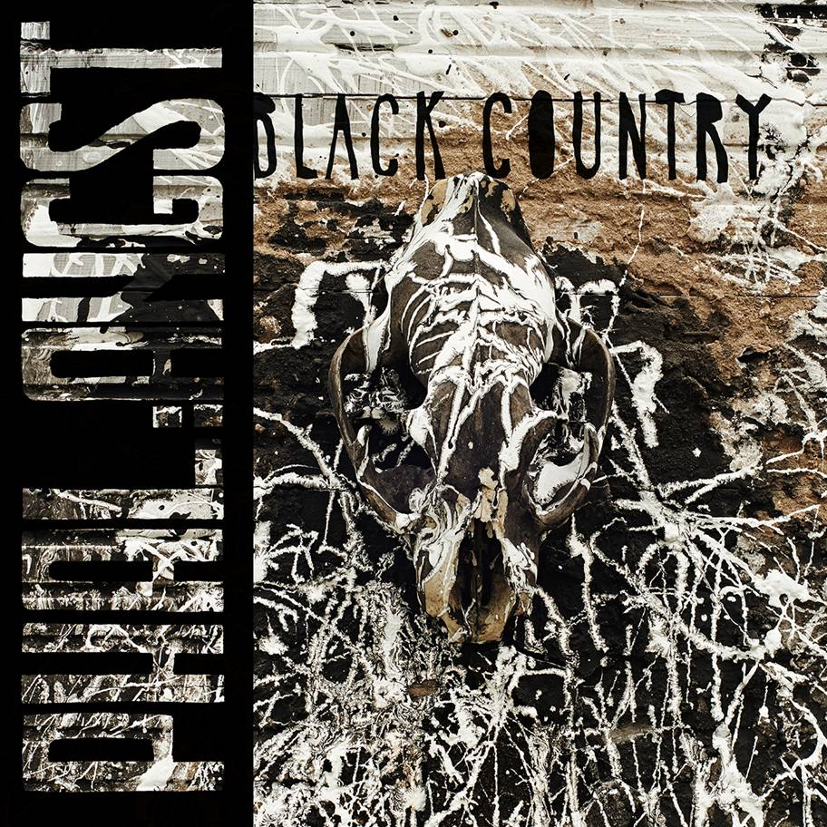
Tracklisting:
1. Hardwire (14:56)
2. Black Country (7:45)
3. The Old Has To Die And The New Must Not Be Born ( 7:49)
4. Black Milk Of Morning (11:45)
5. Theta (12:38)

Phal:Angst is an Industrial/Post-Rock-Band from Vienna/Austria. They formed in 2006 and are about to release their third album on November 14th 2014. File between Industrial, EBM, Post-Rock and Doom and bands like Earth, Mogwai, Coil, Front 242 and Neurosis.
Industrial/EBM-influenced electronics are accompanied by guitar and vocals, where the latter increasingly explore realms of Pop. Synths and E-bass form a bass-heavy fundament, forcing the stereo to ventilate. Kaoss-Pad, harp & xylophone serve as additional phonetic elements, resulting in a cinematic dystopia set to push the boundaries of musical extremity.
"Black Country" was recorded by Alexandr Vatagin (Valeot Records, Slon, Tupolev, Port Royal, Werner Kitzmüller) and mastered by Austrian Techno pioneer Patrick Pulsinger. The stunning artwork was done by Christopher Sturmer (Stirn Prumzer, Atzgerei). "Black Country" will be released as a gorgeous Double Gatefold Vinyl, Digipack-CD and digitally.
At the same time the 2nd album „Shiver With Cold“ is going to be digitally rereleased, a remastered version of their debut „ для одной руки“ will be released on 21st November and the remix album "Black Country Revisited" (featuring chra, Electric Indigo, David Pfister, Rokko Anal, Tronstoner, Swallowredrain and Bastard Sun) on 28th November.

Releaseparty: 5th December 2014, EKH, Vienna/Austria (w Chra, DJ Rokko Angst, Bastard Sun, David Pfister, Swallowredrain, Tronstoner)

All press materials and the full album can be downloaded/streamed here:
www.med-user.net/~bloodshed666/blackcountry

Video „Hardwire“: www.med-user.net/~bloodshed666/hardwirevideo

inform:
www.med-user.net/phalangst - www.facebook.com/phalangst

listen:
www.phalangst.bandcamp.com
www.soundcloud.com/phalangst
www.amazingtunes.com/phalangst

see:
www.youtube.com/bloodshed666records

label:
www.bloodshed666.net

Press matters in Austria: Alfred, indubiocontra@gmail.com, (+43) 650 834 5680
For all other press matters, please contact Tom Brumpton/Polymath PR at tbrumptonpr@gmail.com or (+44) 7956 043 498
Phal:Angst – Black Country Revisited (2014, bs12, digital)
Seven artists did remixes of all tracks featured on „Black Country“. They were completely free to modify the songs as they wanted, resulting in a diversified album. Artists are: Electric Indigo, chra, Tronstoner, Swallowredrain, David Pfister, Rokko Anal & Bastard Sun.
Presssite: www.med-user.net/~bloodshed666/blackcountryrevisited

Phal:Angst – Shiver With Cold (2009, bs13, digital)
Second album, the guitar approaches more and more the Post-Rock genre, electronics are intensified, homemade beats, the songs pick up many motifs of the Saila soundtrack (2008).
Presssite: www.med-user.net/~bloodshed666/shiverwithcold

Phal:Angst - для одной руки (2007, bs14, digital)
The first album from 2006. Gluey and doomy, based on highly slowed down breakbeats.
Presssite: www.med-user.net/~bloodshed666/dniaadnoiruki

