Artist: Phal:Angst  Album: Black Country Revisited  Label: Bloodshed666 Records (bs12)  Distribution: Ordis (digital)  Release date: 28.11.2014 | 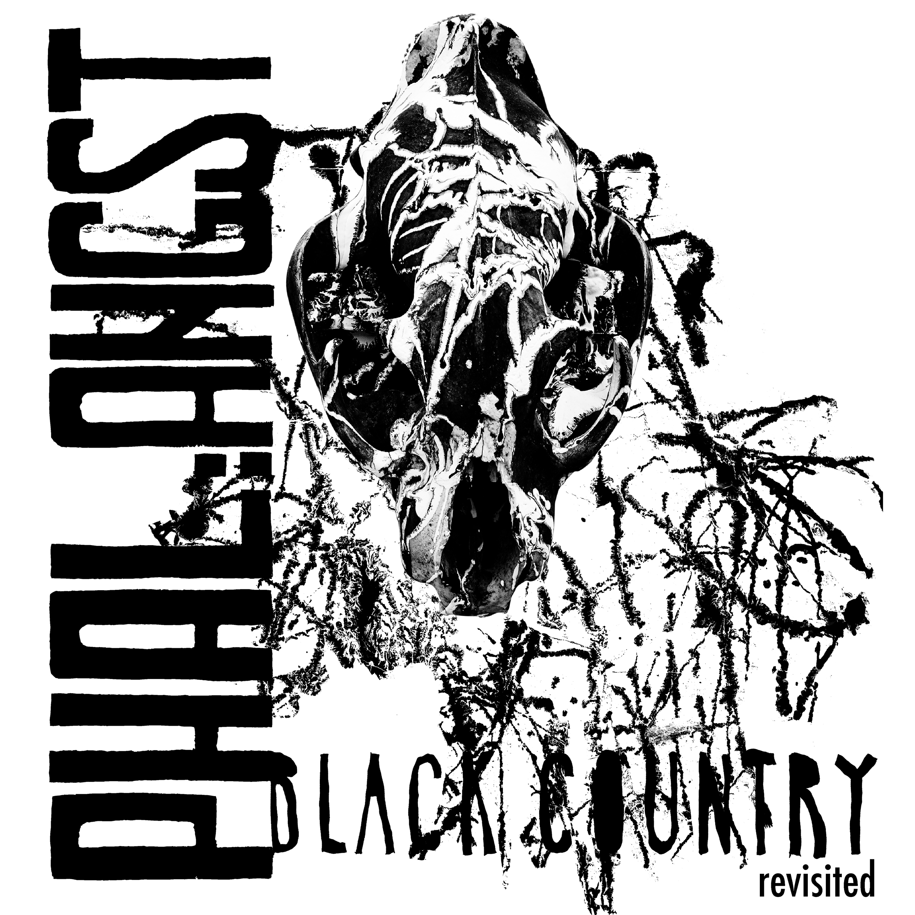

Tracklisting:
1. Black Milk Of Morning (Tronstoner Remix) (09:00)
2. Black Country (Electric Indigo Rework) (06:46)
3. Rewire (Andrej Swallowredrain Remix) (13:53)
4. Black Milk Of Morning (David Pfister Remix) (05:07)
5. Black Country Blues (chra Remix) (04:49)
6. The Old Has To Die And The New Must Not Be Born (Bastard Sun Remix) (05:53)
7. Theta (Rokko Anal Wirtshaus Remix) (04:37)

Phal:Angst is an Industrial/Post-Rock-Band from Vienna/Austria. They formed in 2006 and are about to release their third album „Black Country“ in 2014. File between Industrial, EBM, Post-Rock and Doom and bands like Earth, Mogwai, Coil, Front 242 and Neurosis.

The new album is accompanied by the remix album „Black Country Revisited“. Seven artists did remixes of all tracks featured on „Black Country“. They were completely free to modify the songs as they wanted, resulting in a diversified album. Artists are: Electric Indigo (female:pressure), David Pfister (Devil & The Universe, Neigungsgruppe Sex, Gewalt & Gute Laune, Radio Fm4), chra (female:pressure, Comfortzone, Shampoo Boy, SV Damenkraft), Tronstoner (NSA, Nitro Mahalia, Calamari:Autopsy, Sensual Love, Dieter von Kroll Experience, EyeBM), Bastard Sun (Adaevarath, Create & Destroy Press), Rokko Anal (Rokko's Adventures, Rokko Anal & The Coathangers) & Andrej Swallowredrain.

Presssite: www.med-user.net/~bloodshed666/blackcountryrevisited

inform:
www.med-user.net/phalangst
www.facebook.com/phalangst

listen:
www.phalangst.bandcamp.com
www.soundcloud.com/phalangst
www.amazingtunes.com/phalangst

see:
www.youtube.com/bloodshed666records

label:
www.bloodshed666.net

PR: Alfred, indubiocontra@gmail.com, (+43) 650 834 5680

Phal:Angst – Black Country (2014, bs11, Cargo / Hoanzl / digital)
Industrial/EBM-influenced electronics are accompanied by guitar and vocals, where the latter increasingly explore realms of Pop. Synths and E-bass form a bass-heavy fundament, forcing the stereo to ventilate. Kaoss-Pad, harp & xylophone serve as additional phonetic elements, resulting in a cinematic dystopia set to push the boundaries of musical extremity.
"Black Country" was recorded by Alexandr Vatagin (Valeot Records, Slon, Tupolev, Port Royal, Werner Kitzmüller) and mastered by Austrian Techno pioneer Patrick Pulsinger. The stunning artwork was done by Christopher Sturmer (Stirn Prumzer, Atzgerei). "Black Country" will be released as a gorgeous Double Gatefold Vinyl, Digipack-CD and digitally.
At the same time the remix album "Black Country Revisited" (featuring remixes by Chra, Electric Indigo, David Pfister, Rokko Anal, Tronstoner, Swallowredrain and Bastard Sun) and the first two albums are going to be digitally (re)released.
Presssite: www.med-user.net/~bloodshed666/blackcountry

Phal:Angst – Shiver With Cold (2009, bs13, digital)
Second album, the guitar approaches more and more the Post-Rock genre, electronics are intensified, homemade beats, the songs pick up many motifs of the Saila soundtrack (2008).
Presssite: www.med-user.net/~bloodshed666/shiverwithcold

Phal:Angst - для одной руки (2007, bs14, digital)
The first album from 2006. Gluey and doomy, based on highly slowed down breakbeats.
Presssite: www.med-user.net/~bloodshed666/dniaadnoiruki

